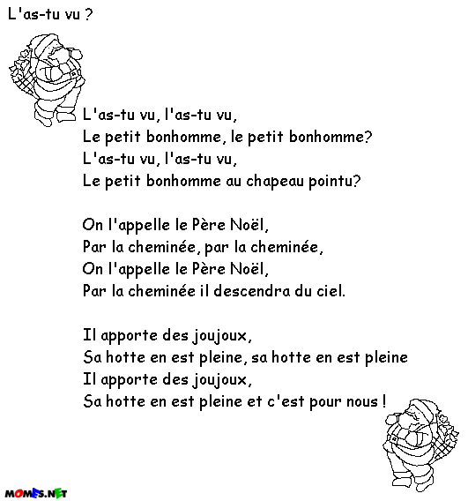

©1995-2000 info@momes.net infomomes.net

